Language: English
THE African Development Bank Group

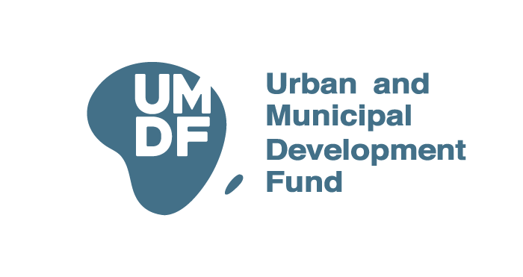

URBAN AND MUNICIPAL DEVELOPMENT FUND

UMDF PROJECT BRIEF
[Title of Project]
[City, COUNTRY]
[Total GRANT amount REQUESTED]
date: [MONTH-yyyy]

Key Project Information
Project title | [please select a short appropriate title of the project]
Sector | [select most appropriate sector]
Location | [Country] |  |  |  |  |  |  |  |  | [City/local authority]
Client | [Name the client and beneficiary of the project]
Executing Agency | [The project proposing, owning Institution]
Team Leader | [Name, Function, E-Mail, 9am-5pm working telephone contact]
Task Team | [add line if other key people are involved, esp if this is already reviewed by AfDB Staff]
Project Origin | [Please indicate the origin of this project]
For AfDB internal use only | AfDB Country Program Officer
 | AfDB Urban Regional Focal Point
Strategic Context
Country Policy Alignment | Policy / Plan |  |  |  | Priorities Supported by Project |  |  |  |  |  |  |  |  | Alignment
 | [Key statutory polices/plans] |  |  |  | [which priorities in those policies plans will support the project] |  |  |  |  |  |  |  |  | [how does the project help achieve those]
 | [add lines if necessary]
Sustainable Development Goals (SDGs) | [name the 1-2-3 most relevant SDGs, if possible with target the project helps to achieve]
African Union Agenda 2063 | [list which AU 203 Agenda goals are supported by the project]
AfDB High 5s | [name the most appropriate High 5 supported by the project]
AfDB Country Strategy Paper | [reference the CSP and the priority the project supports]
Climate Change | [How does the project help achieve mitigation/adaptation]
Sector and Institutional Context
Project Description
Project Objective | [The objective of the project should be clearly defined and brief – 1 sentence max].
Theory of Change | This section should summarize the rationale / relevant background to the project, i.e. why is the project needed and some context.
Project Description / Components | This section should describe proposed project in detail, including key technical features, proposed scope of works, etc up to a maximum of 200 words, with a clear indication of the project components / sub-components.  Component 1: Name, [Description of component goal, activities, target beneficiaries etc]  Component X: Name, [Description of subcomponent goal, activities, target beneficiaries etc]
Key Impacts and Outcomes of Project | Environment and Climate
 | Social and Gender
 | Economic and Financial
Project Target Area | This section should list where the project will be implemented, and at what scale. Where applicable, coordinates should be included here and a map added in the Annex.
Status of Preparation | This section should provide an indication the current status of project implementation, e.g: Project idea, Concept note / pre-feasibility study, Project proposal including feasibility study, Under implementation / for scaling up
Next Steps | This section should briefly outline next steps in the origination and preparation. It should also include an estimate of the time until the project is operational.
 | Proposed Activity |  |  |  |  |  | Duration |  |  |  |  |  |  |  | Responsible
 | [add lines if necessary]
Stakeholders and Beneficiaries
Key Stakeholders | Category |  |  | Stakeholder [also include below the client]
 | National Government
 | Local Government
 | Private Sector
 | Civil Society
 | Development Partners |  |  | [Others (please specify) and/or add lines]
Direct Beneficiaries | Group |  |  | Estimated Number |  |  |  |  |  |  | Development Impact
 | [List beneficiary group 1] |  |  | [estimated number of beneficiaries, men and women and any further breakdown that might be useful, i.e. youths] |  |  |  |  |  |  | [Explain any pronounced development impacts that will be achieved by the project, e.g. for mobility project, travel time reduction, new public transit option for % of population etc.]
 | [add lines if necessary]
Financial Information
Estimated Project Cost |  | Components |  |  |  | Amount (US$) |  |  | % of Total Cost |  |  | Source
 |  | Total Amount: |  |  |  |  |  |  | 100%
Amount of Preparatory Financing needed
 |  | [add lines if necessary]
Client Co-Financing |  | [Estimate of cost to be covered by the project owner.]
3rd Party Co Financing |  | [Please document third party financial commitments here]
Remaining Financing Need |  | Estimate of financing gap should be provided here.
Financing Approach |  | This section should elaborate on any defined or proposed financing approach (Sovereign loan, grant, PPP, private sector etc).
Private Sector Involvement |  | This section should include more information about possible private sector participation in the project (if applicable).
Revenue Opportunities |  | This section should include information about possible or expected revenue generation from the project, if any.
Project Risks
Risk Area | Potential Risk |  |  | Estimated Category |  |  |  |  |  |  |  |  | Mitigation Measure
Environmental and Social Safeguards | [List any identified key environmental and social risks that the project may entail] |  |  | [Please select your answer as per AfDB criteria (see footnote) and delete all other options]  ☐ Category 1: Significant Impacts  ☐ Category 2: Less Adverse Impacts than Category 1  ☐ Category 3: Negligible Adverse Risks |  |  |  |  |  |  |  |  | [Indicate possible measures to mitigate the identified risks]
Involuntary Resettlement Foreseen |  |  |  | ☒ Yes | ☐ No | ☐ To be confirmed |  |  |  |  |  |  |  |  | [Indicate possible measures to avoid or mitigate involuntary resettlement and related risks]
Climate Safeguards | [List any identified key climate risks that the project may entail] |  |  | [Please select your answer as per AfDB criteria (see footnote) and delete all other options]  ☐ Category 1: Very vulnerable  ☐ Category 2: Vulnerable  ☐ Category 3: Not vulnerable |  |  |  |  |  |  |  |  | [Indicate possible measures to mitigate the identified risks]
Gender Marker System | [List any identified key gender risks that the project may entail] |  |  | [Please select your answer as per AfDB criteria (see footnote) and delete all other options]  ☐ Category 1: Gender Principal Objective  ☐ Category 2: Gender One of the Outcomes  ☐ Category 3: Gender One of the Outputs  ☐ Category 4: Marginal Gender Elements / Inclusive Activities |  |  |  |  |  |  |  |  | [Indicate possible measures to mitigate the identified risks / enable gender opportunities]

Annex Checklist
☐ Government Request/Support Letter(s)
☐ Further information you may have: project map(s), presentation(s), concept note(s)
☐ Draft Terms of References

Please Note:
1. Any project brief must be accompanied by a request letter from the respective local and national authority, addressed to the AfDB Country Manager or the Director, Infrastructure and Urban Development Department.
2. Please provide further information you may have through annexes, project maps, presentations, concept notes etc.
3. Investment focus: Please focus this template on the investment project, and not on the UMDF grant.

https://www.afdb.org/en/documents/document/afdbs-integrated-safeguards-system-policy-statement-and-operational-safeguards-34993
https://www.afdb.org/fileadmin/uploads/afdb/Documents/Policy-Documents/10000009-EN-BANK-GROUP-INVOLUNTARY-RESETTLEMENT-POLICY.PDF
https://www.afdb.org/fileadmin/uploads/afdb/Documents/Generic-Documents/CSS%20Basics-En_def.pdf
https://www.afdb.org/en/documents/african-development-bank-gender-marker-system-gms

